**Component of React Js**

We use functional component for normal uses and When we create a normal project then we use functional Component

There are two types of Component:

1. Functional Component
2. Class Component

We use class component for complex uses. And when we create a complex project then we use class component

**Functional Component:**

**What is a component?**

= A bunch of html,css and js code that once we created and use it for multiple times in our projects.

Main thing we have to remember that the first letter of the component name must be uppercase letter

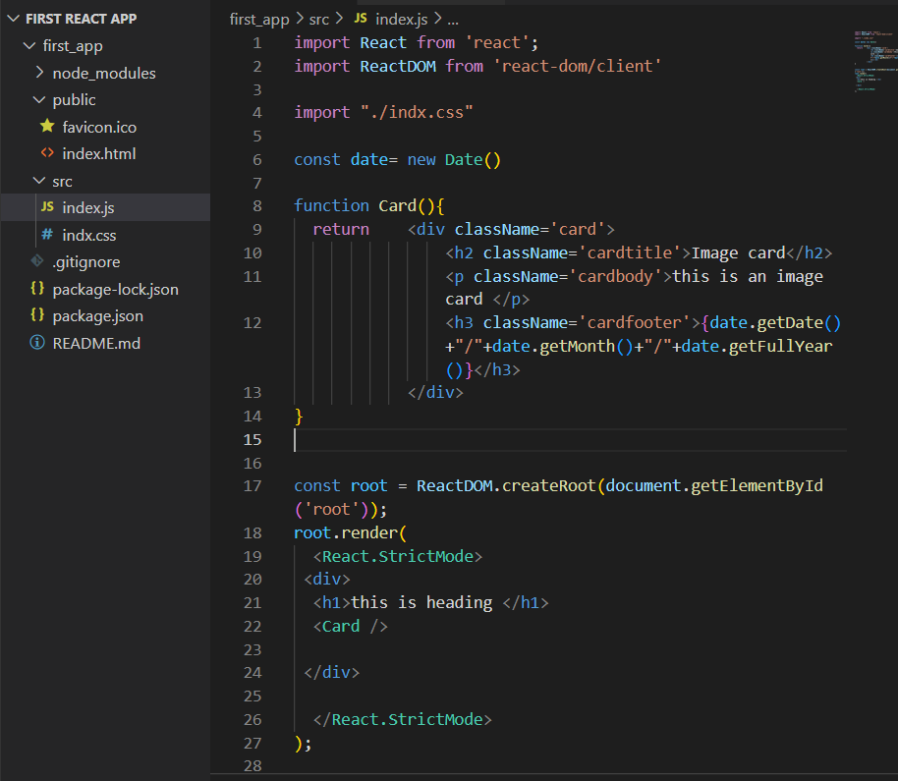

This is a component and we can use it multiple times in our projects

Note: Remember one thing that, the first letter of the component name must be in uppercase letter otherwise it will not work in the project



Calling of the components and the first letter of the component must be in uppercase letter

The first letter of the components must be in uppercase letter

**Class Component:**

When we create a complex project then we use class component.

**How we use class component?**

1st of all create a class_component.js file

Then ,

Import React component

Class name

Import React,{Component} from “react”

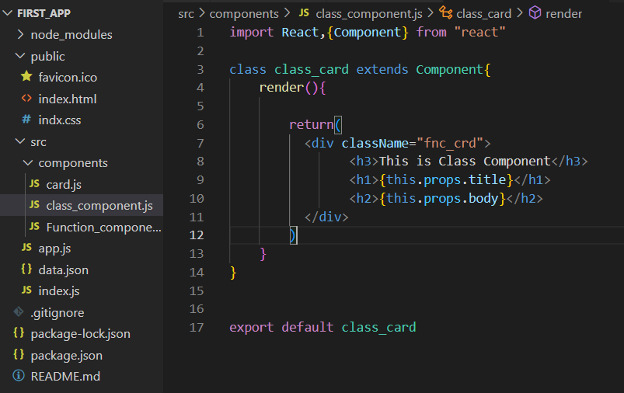

This is how we can access data from app

Must need rendering

Create a class component

In the app.js

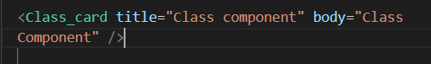

After complete the class card

